# Entity Framework Database First Demo

create database EFDatabaseFirstDB

use EFDatabaseFirstDB

create table Products

(

ProductID int primary key identity(1001,1),

Name char(30) not null,

Price int not null,

Quantity int not null

)

insert into Products values

('HP Keyboard',400,10),('Dell Mouse',260,20),('Sandisk Pendrive',450,5)

Select * from Products

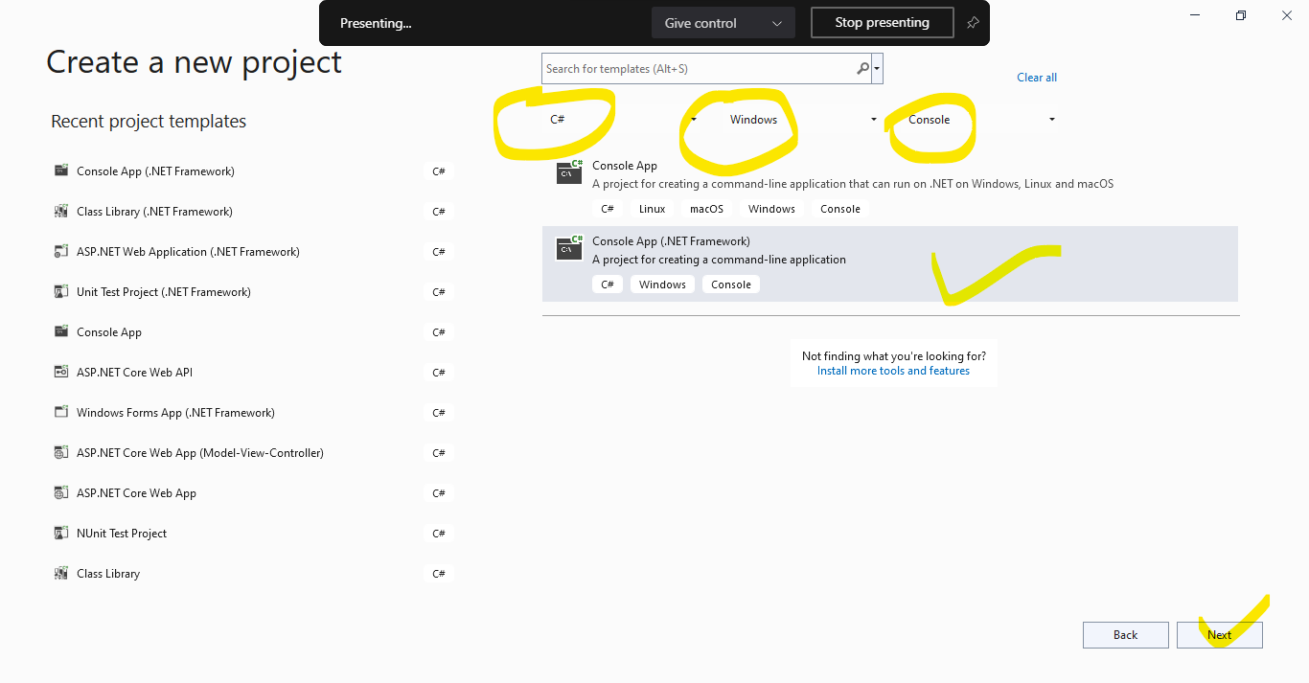

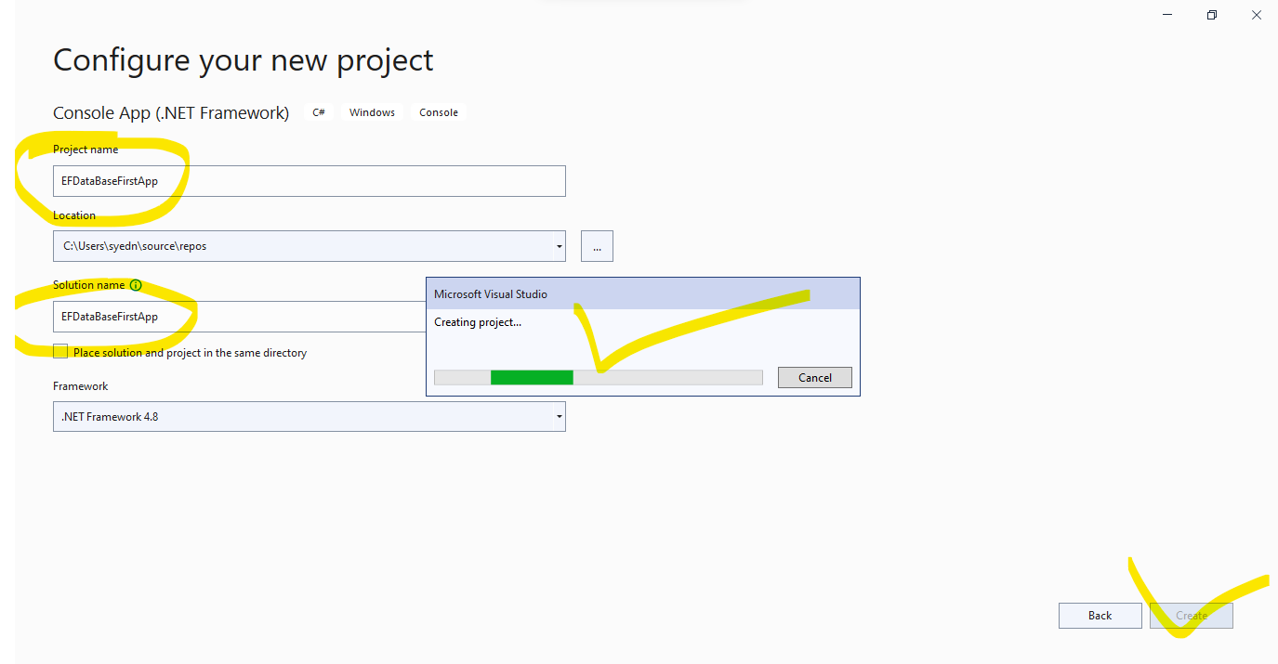

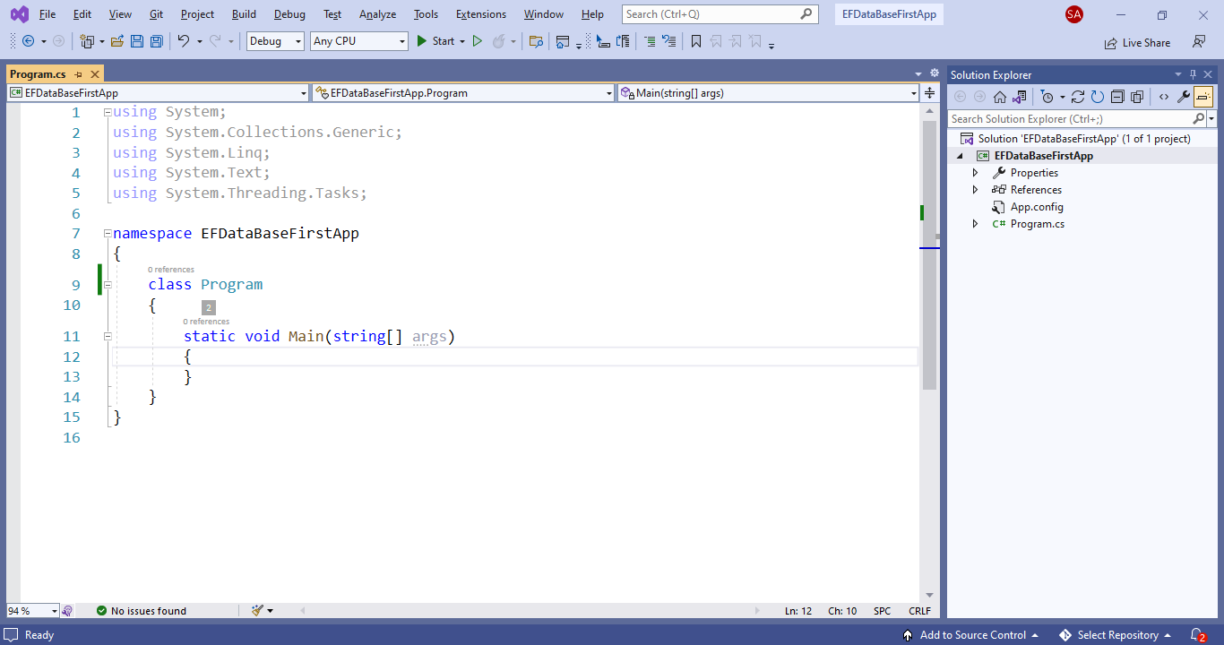

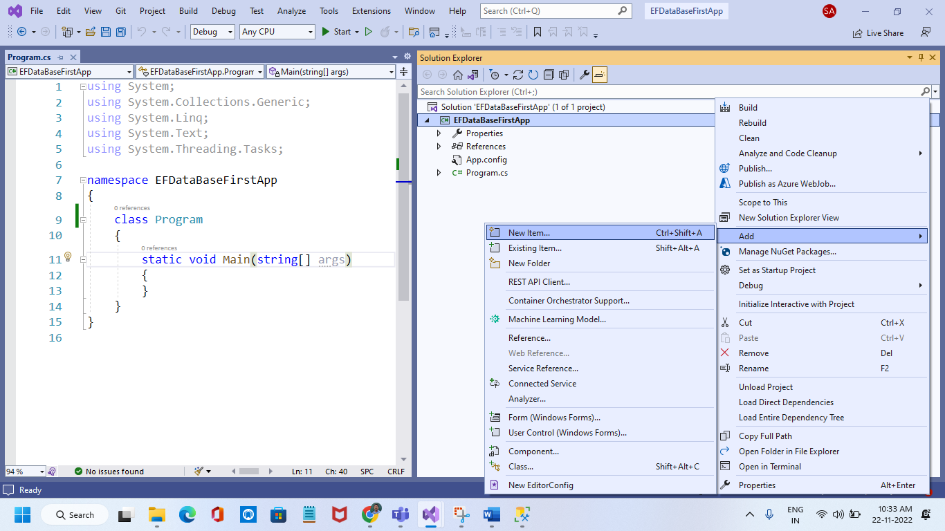

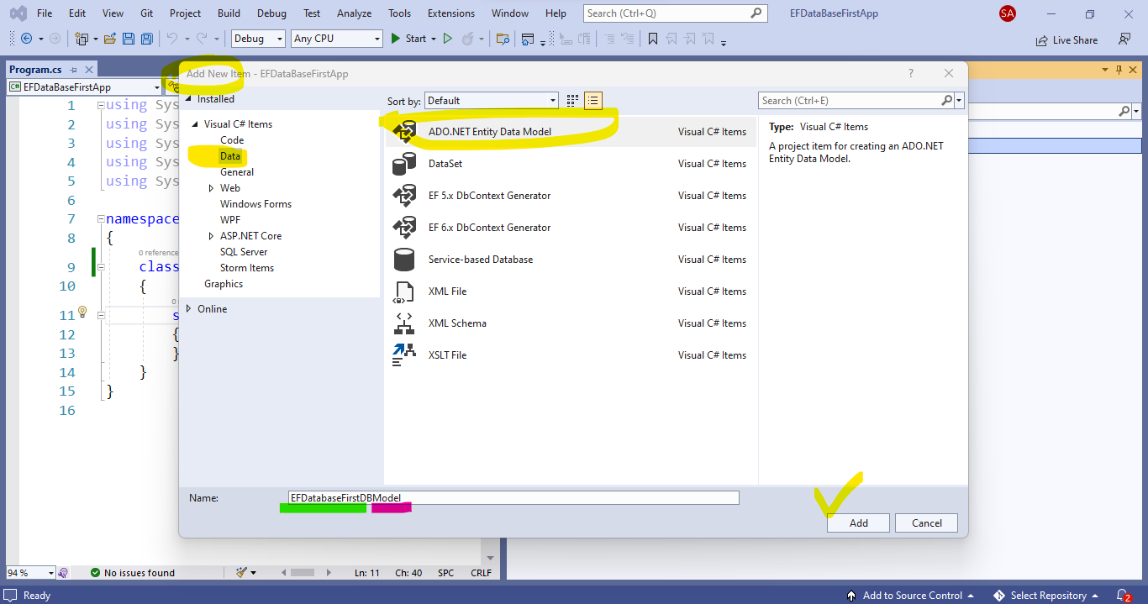

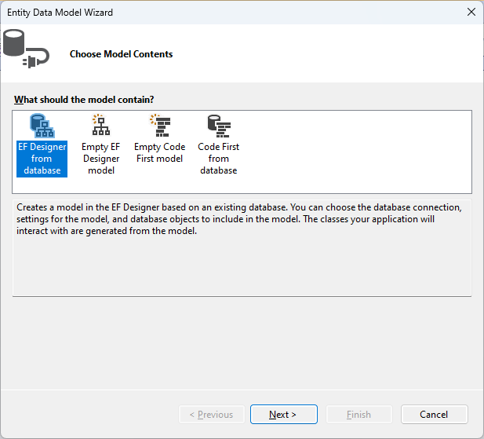

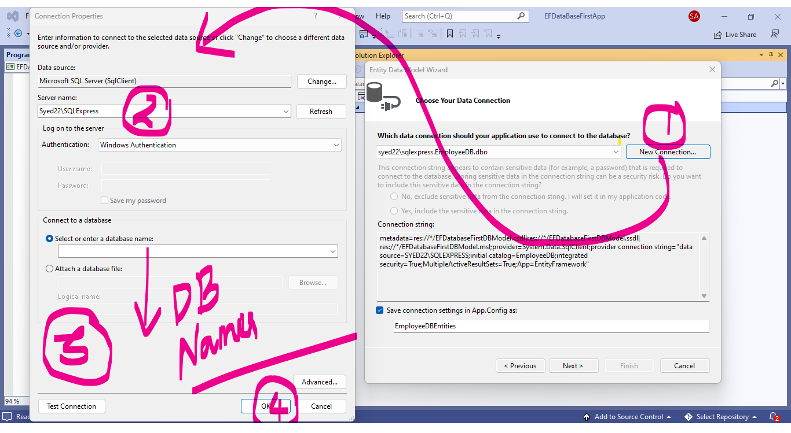

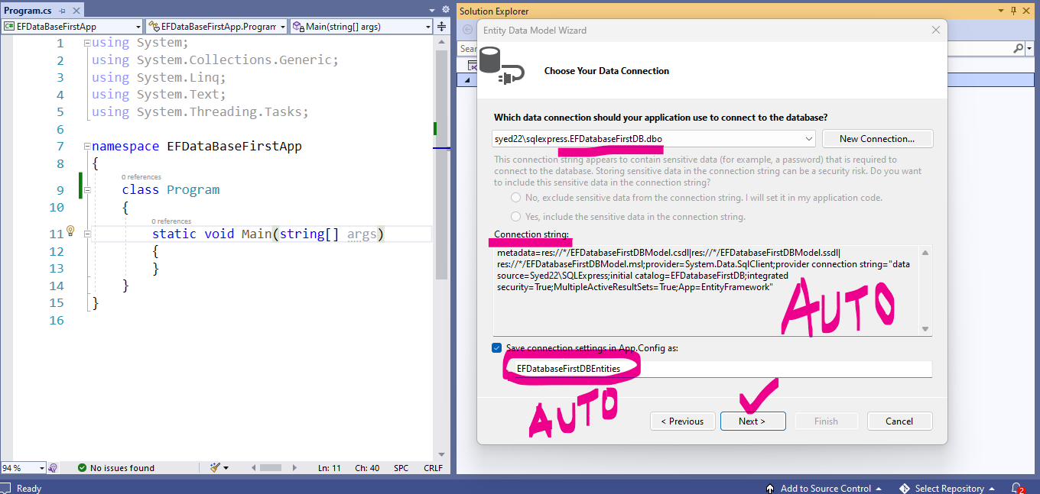

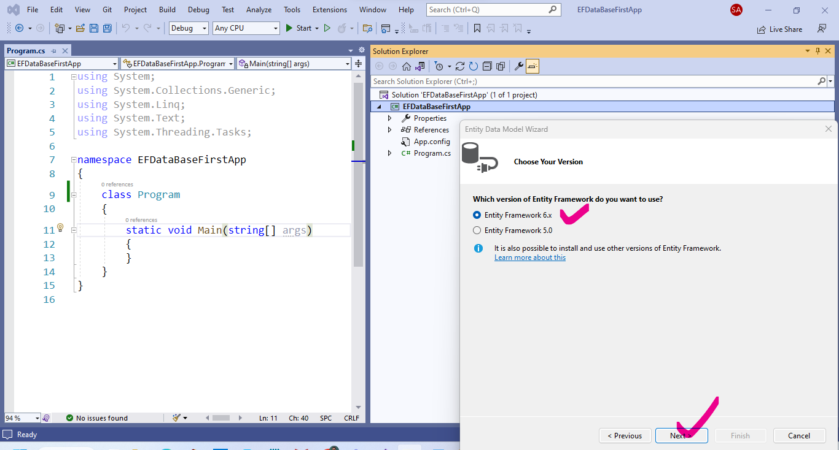

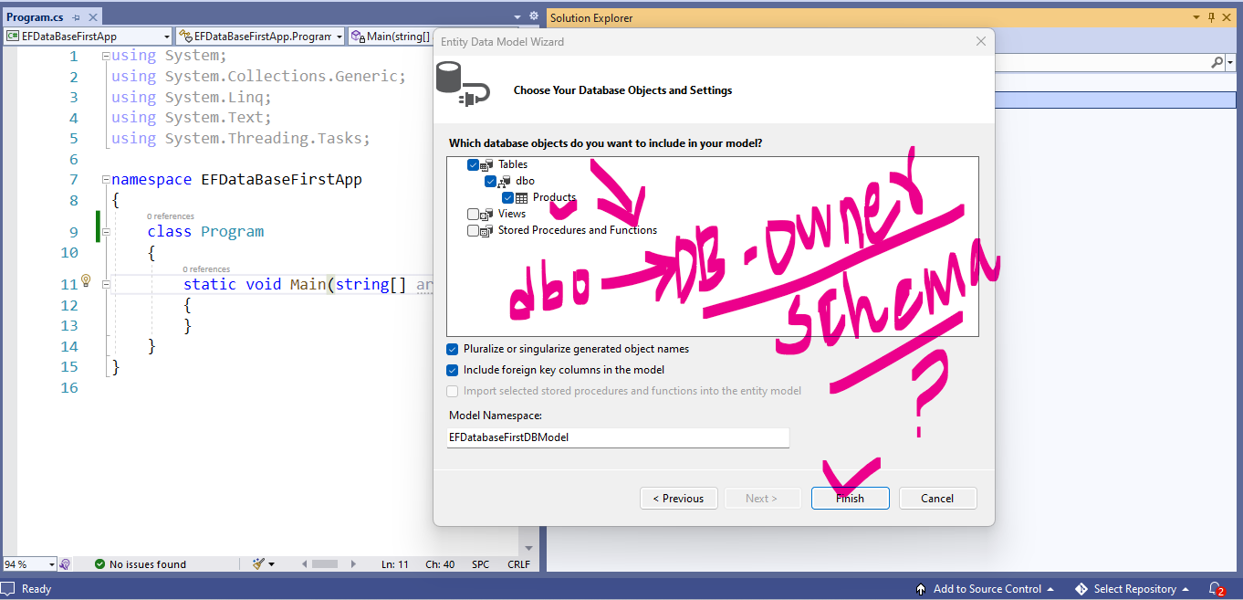

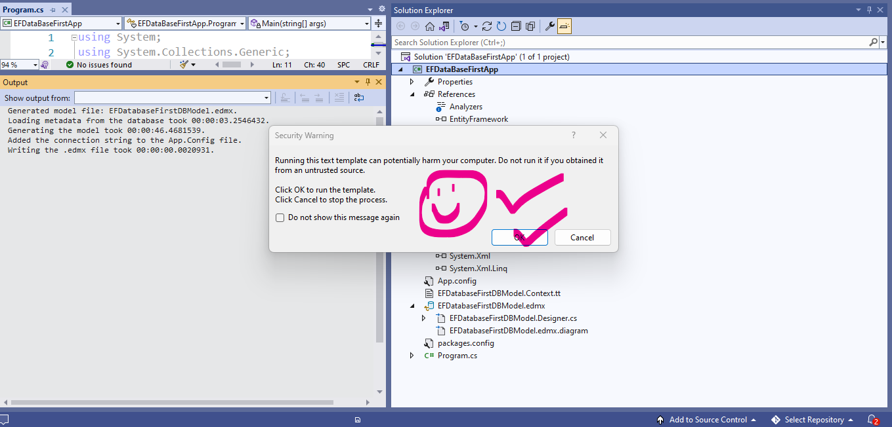

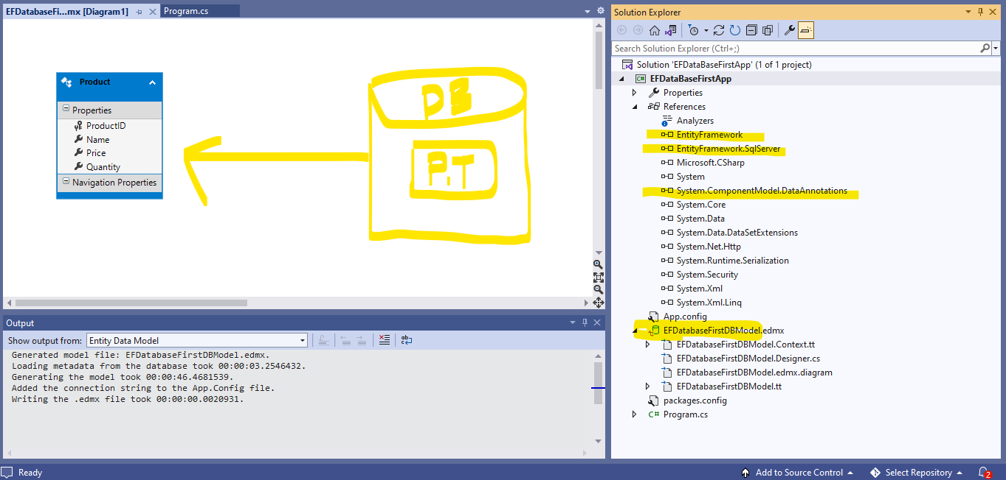

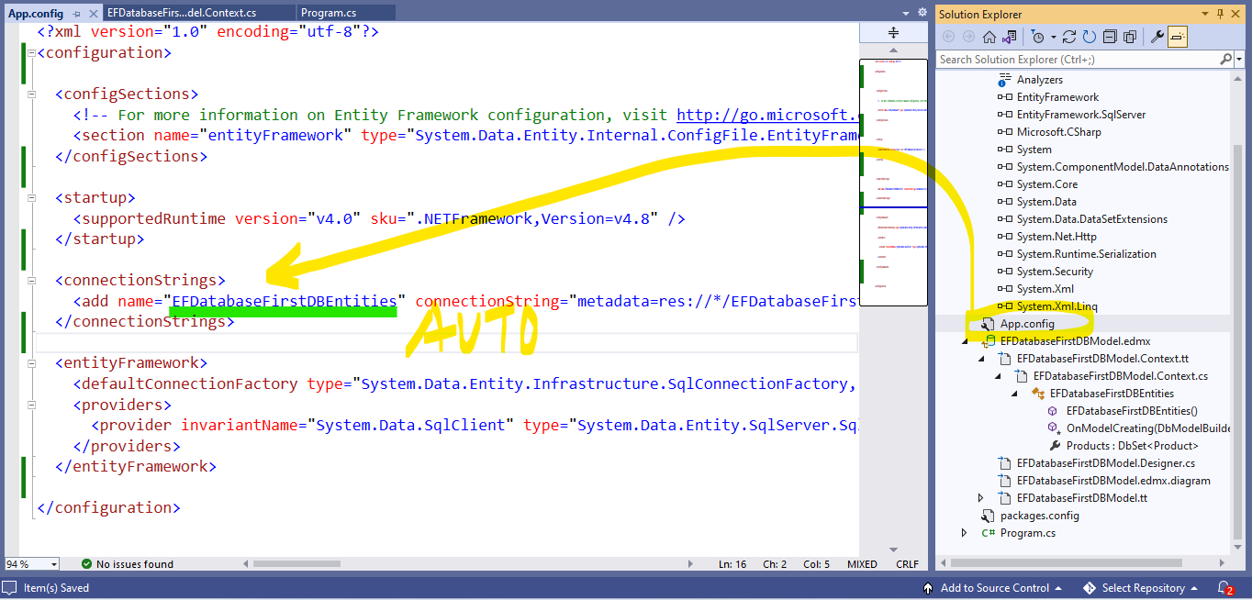

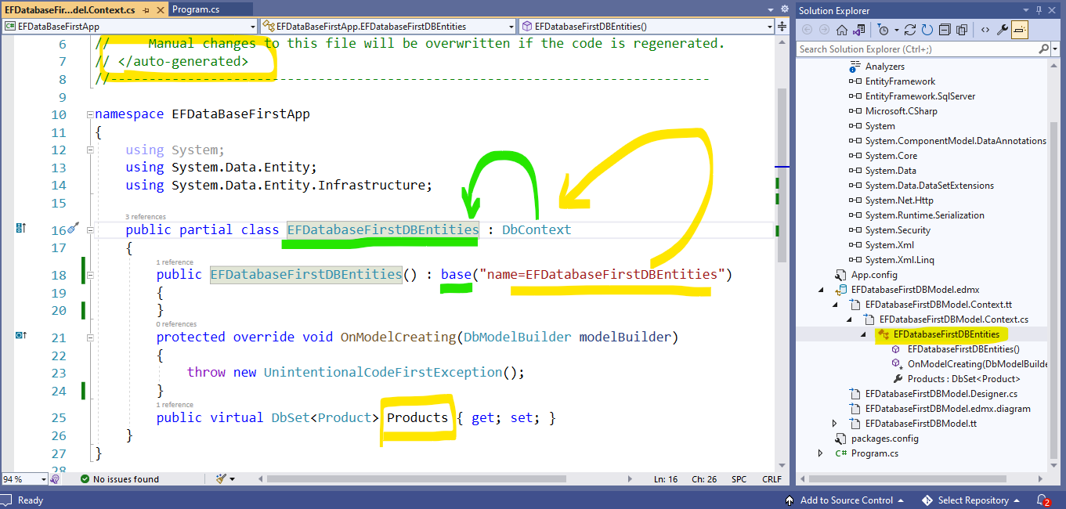

using System;

using System.Collections.Generic;

using System.Linq;

using System.Text;

using System.Threading.Tasks;

namespace EFDataBaseFirstApp

{

class Program

{

static void Main(string[] args)

{

EFDatabaseFirstDBEntities context = new EFDatabaseFirstDBEntities();

int choice;

do

{

//CRUD

Console.WriteLine("Product Database Application");

Console.WriteLine("1.Create\n2.Display\n3.Update\n4.Delete\n5.Exit");

Console.WriteLine("Enter your Choice");

choice = int.Parse(Console.ReadLine());

switch (choice)

{

case 1: //create

Product product= new Product();

Console.WriteLine("Enter Product Name");

product.Name = Console.ReadLine();

Console.WriteLine("Enter Product Price");

product.Price = int.Parse(Console.ReadLine());

Console.WriteLine("Enter Product Quantity");

product.Quantity = int.Parse(Console.ReadLine());

context.Products.Add(product);

context.SaveChanges();

Console.WriteLine(product.Name + "'s Record Inserted Successfully");

break;

case 2: //Read

break;

case 3: //Update

break;

case 4: //Delete

break;

case 5:

Console.WriteLine("Thank you. Visit again");

Console.ReadKey();

break;

default:

Console.WriteLine("Invalid choice enter between 1 to 5.");

Console.ReadKey();

break;

} //switch..

} while (choice != 5);

Console.ReadKey();

}

}

}

